MADHA INSTITUTE OF ENGINEERING AND TECHNOLOGY NM ID: 211221104019

PUBLIC TRANSPORTATION AND OPTIMIZATION

Internet of things - group 1 - Phase_4

developing public transportation systems involves a complex interplay of various factors, including emciency, safety, and sustainability. Integrating the Internet of Things (IoT) into

public transportation can signiﬁcantly enhance the optimization of these systems. Here's an outline of how IoT can be applied to optimize public transportation:

# Real-time monitoring and management:

Implement IoT sensors and devices on buses, trains, and trams to monitor their location, speed, and condition. This data can be utilized to manage routes in real-time, ensuring optimal utilization of resources and minimizing delays.

# Passenger information and communication:

Deploy IoT-enabled displays at bus stops, train stations, and transit hubs to provide real-time information about arrival times, delays, and alternative routes. Additionally, develop mobile applications for passengers to access information and provide feedback, enhancing the overall user experience.

# Predictive maintenance:

Utilize IoT sensors to collect data on the condition of transportation vehicles. By analysing this data, you can predict maintenance requirements, reducing the risk of unexpected

breakdowns and ensuring the safety of passengers and staff.

# Traffic management and optimization:

Integrate IoT sensors with tramc lights and road infrastructure to manage tramc ﬂow more emciently. This can reduce congestion, minimize travel times, and improve the overall

transportation experience for commuters.

# Fleet management and optimization:

Use IoT devices to track and manage the entire ﬂeet, optimizing routes, fuel consumption, and maintenance schedules. This can lead to cost savings, improved operational emciency, and reduced environmental impact.

# Safety and security:

Implement IoT-enabled surveillance cameras and sensors to enhance security measures on public transportation. This can help in monitoring and addressing safety concerns in real- time, ensuring a secure environment for passengers.

# Environmental impact monitoring:

Employ IoT devices to monitor environmental factors, such as air quality and emissions, within the public transportation system. This data can be used to assess the environmental impact and implement measures to reduce the carbon footprint of the transportation

network.

# Data analytics and decision-making:

Collect and analyse the data gathered through IoT devices to identify patterns, trends, and areas for improvement within the public transportation system. Use these insights to make data-driven decisions and optimize the system further.

# Integration with smart city initiatives:

Align the IoT-enabled public transportation system with broader smart city initiatives, fostering a seamless and integrated urban environment that prioritizes sustainability, emciency, and the well-being of its residents.

*By leveraging IoT technology in these ways, public transportation systems can be optimized for enhanced enciency, safety, and sustainability, ultimately providing a more seamless and user-friendly experience for commuters*.

# Web Application (Python and Flask):

Create a web-based platform for administrators to monitor and manage smart restrooms. Use Flask for building the web application.

Implement user authentication for administrators.

Display real-time data from IoT devices, such as occupancy status and supply levels. Provide an interface for administrators to remotely control devices (e.g., ﬂush toilets, unlock doors).

Implement data analytics and reporting

# IoT Device Code (Python and Raspberry Pi):

Use Raspberry Pi or similar devices to control sensors and actuators. Write Python scripts to interact with sensors and control devices.

Use MQTT or other IoT communication protocols to send data to the cloud platform. Implement predictive maintenance algorithms using machine learning libraries.

# Mobile App (Android/iOS):

Develop a mobile app for users to ﬁnd nearby smart restrooms. Enable QR code or NFC functionality for touchless access.

Implement user reviews and ratings for restrooms. Include user-friendly interfaces for navigation.

# Cloud Infrastructure:

Set up a cloud server for data storage and processing.

Use databases for storing sensor data and user information. Implement security protocols for data protection.

# An example sensor used in our technology

Python and Raspberry Pi:

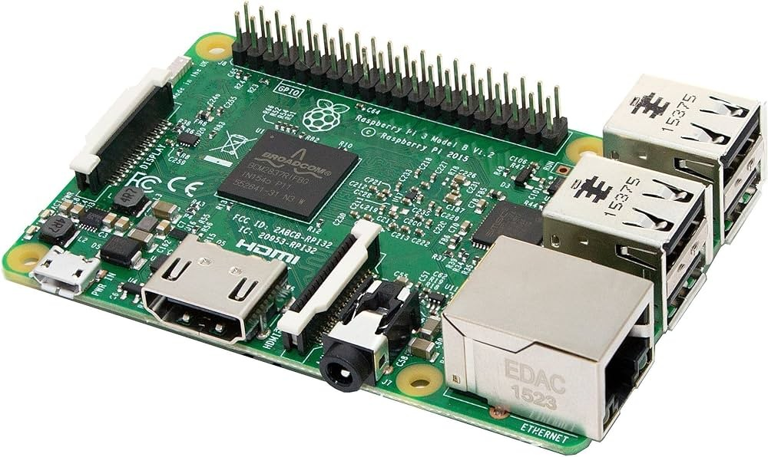

PIR sensor:

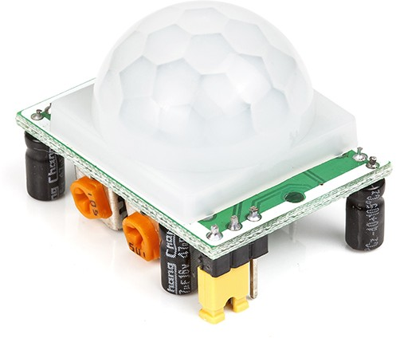

Moisture sensor:

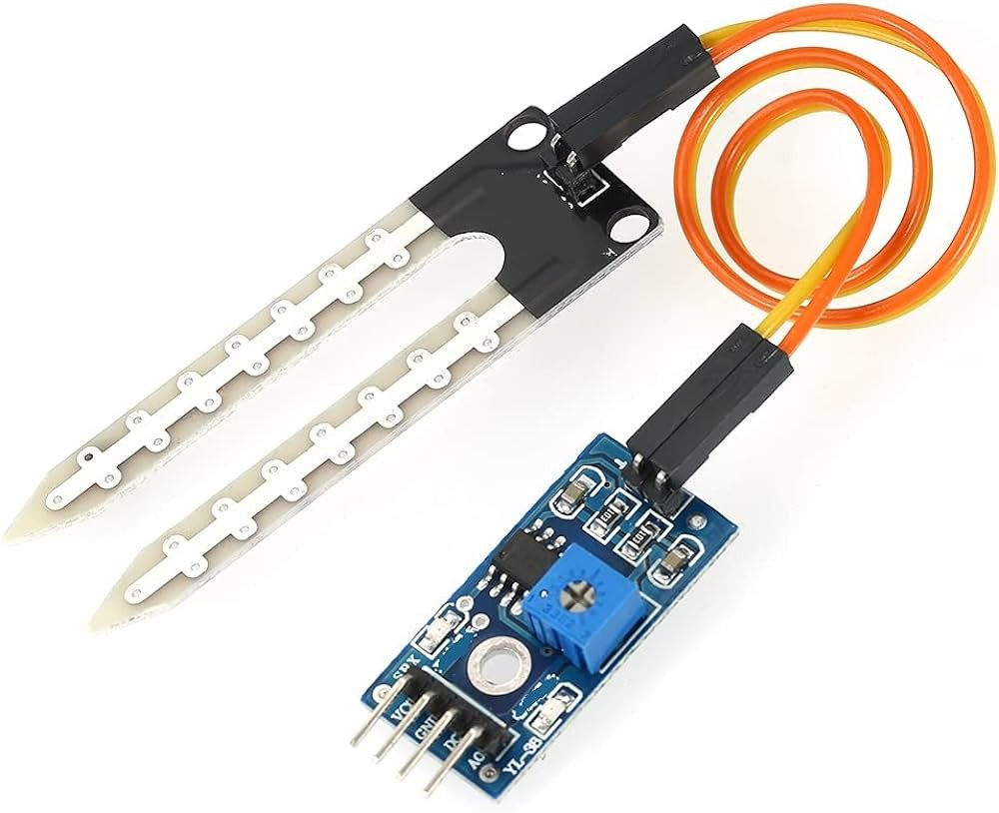

**TEAM MEMBERS:**

**211221104014**

**211221104015**

**211221104016**

**211221104017**

**211221104018**

**211221104019**